CSA1701-ARTIFICIAL INTELLIGENCE

NAME: A . Sri rama krishna
REG NO:192465011
BFS PROBLEM
Aim:
To write a Python program to implement Breadth First Search (BFS) for traversing a graph.
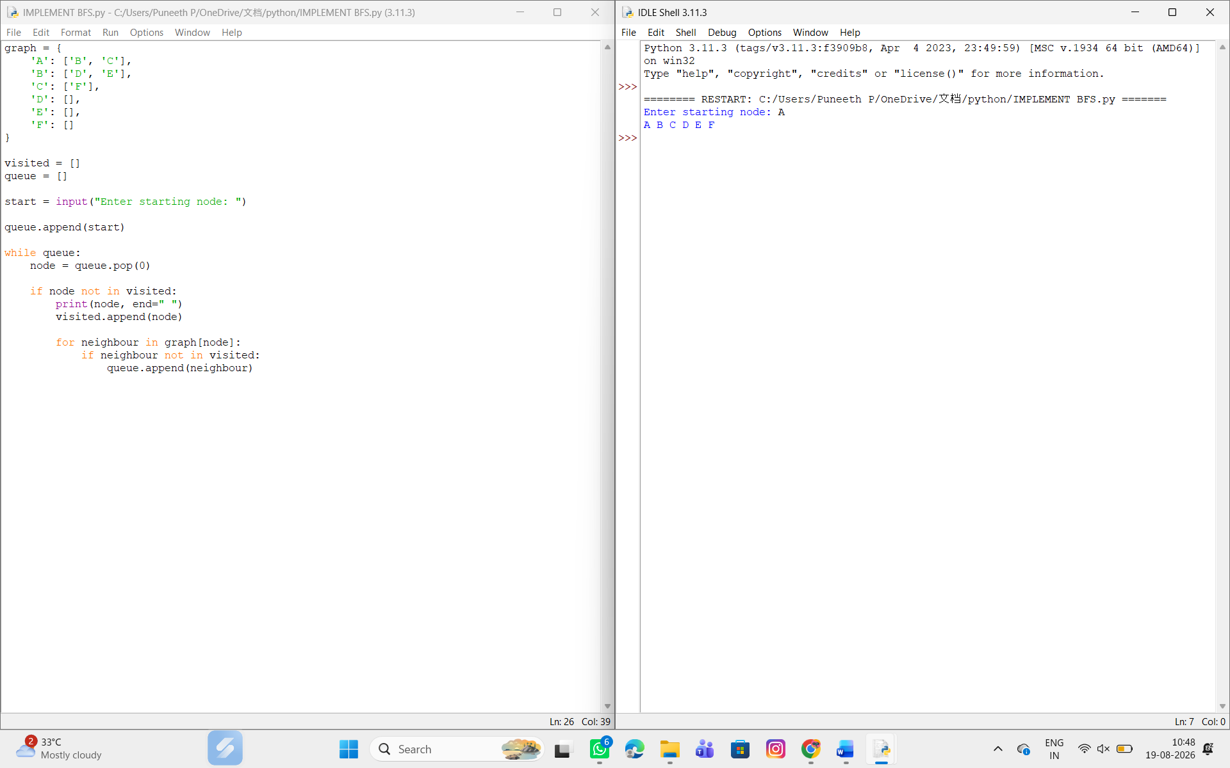

Result:
Thus, the Breadth First Search (BFS) algorithm was successfully implemented using Python.

